# A logo of a company Description automatically generatedSri Lanka Institute of Information Technology

# SE3050 – User Experience Engineering

# Milestone 04: Sketches & Wireframes

**Group:** Native Coders

IT21118340 Kumarathunga S. A. D. S.

IT21291364 Rashen W.G.M

IT21267772 Kumanayake I. A.

IT21388934 Siriwardhana S.M.R.R

**Sketches**

|  |  |
| --- | --- |
| IT21118340 | Kumarathunga S. A. D. S |

|  |  |
| --- | --- |
| IT21291364 | Rashen W.G.M |

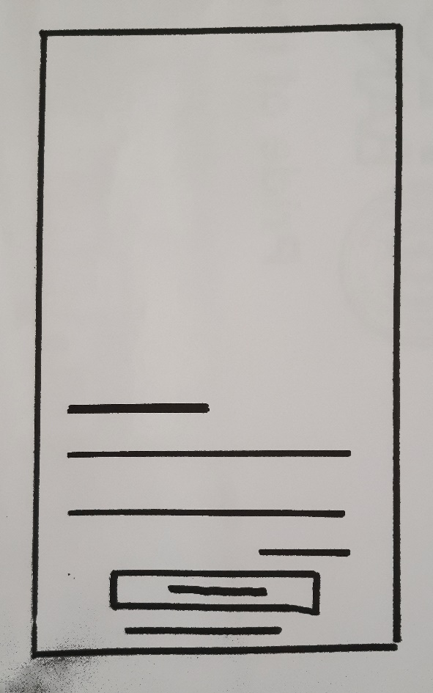

**Login Page**

Enter User name

Enter Password

Forgot password (Hyperlink)

Login (Button)

Register (Button)

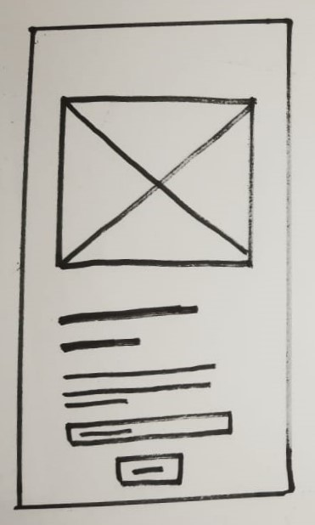

**Forgot Password**

Description about forgot password.

Enter registered email address

Submit (Button)

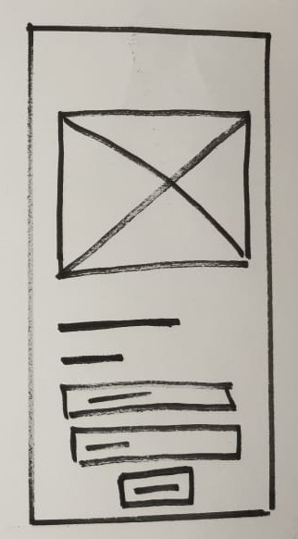

**Reset Password (Forgot Password)**

Enter User name

Enter Password

Submit (Button)

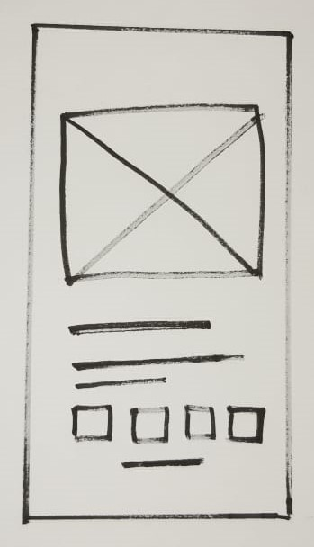

**Enter OTP (Forgot Password)**

Details with registered mobile number

OTP entering blanks.

Resend OTP( Hyperlink)

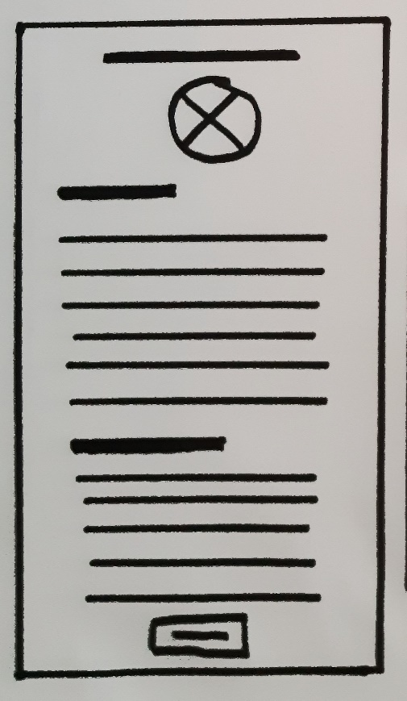

**Tutor Sign Up**

Add profile image

Add personal details

Add academic details

Submit (Button)

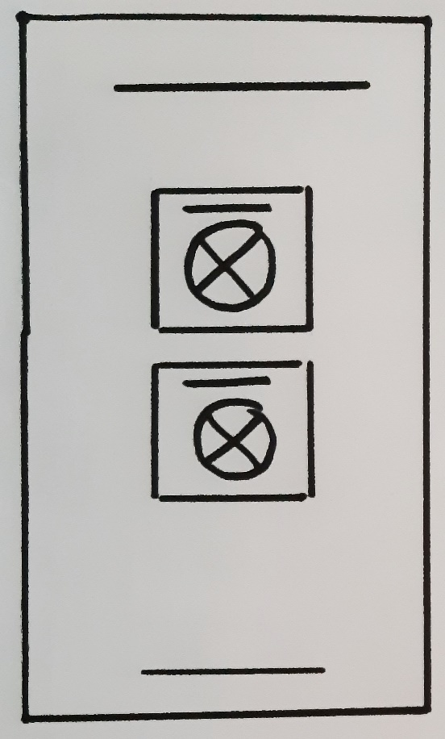

**Sign up Options**

Sign up as a student

Sign up as a tutor

Login (Hyperlink)

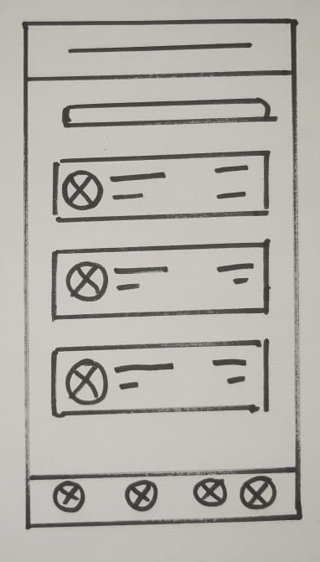

**Tutor List**

Search button

Tutor Component

Level

Name

Rating

Subjects

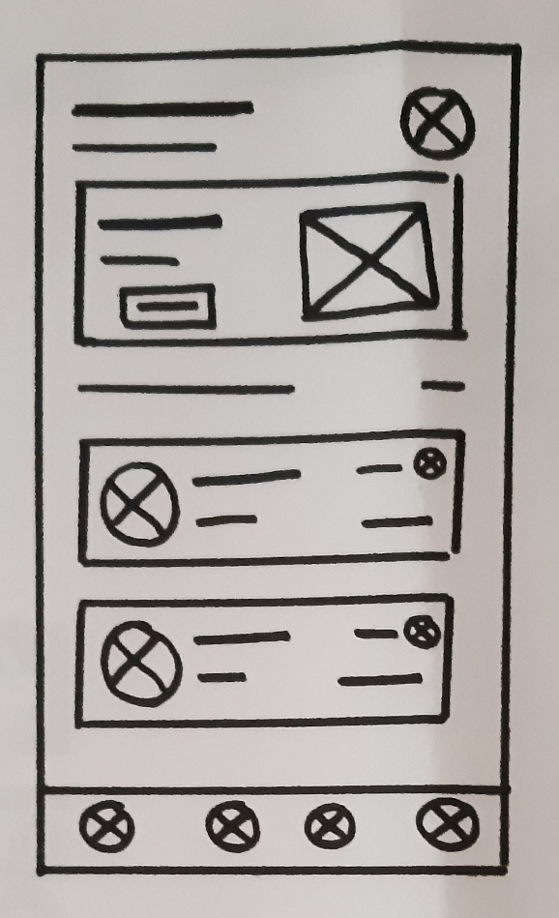

**Home Page(Student View)**

User name

Explore Details of tutors(Button)

Tutor Component

Level

Name

Rating

Subjects



**Tutor Edit Profile**

Edit profile image

Personal details edit

Academic details edit

Submit (Button)

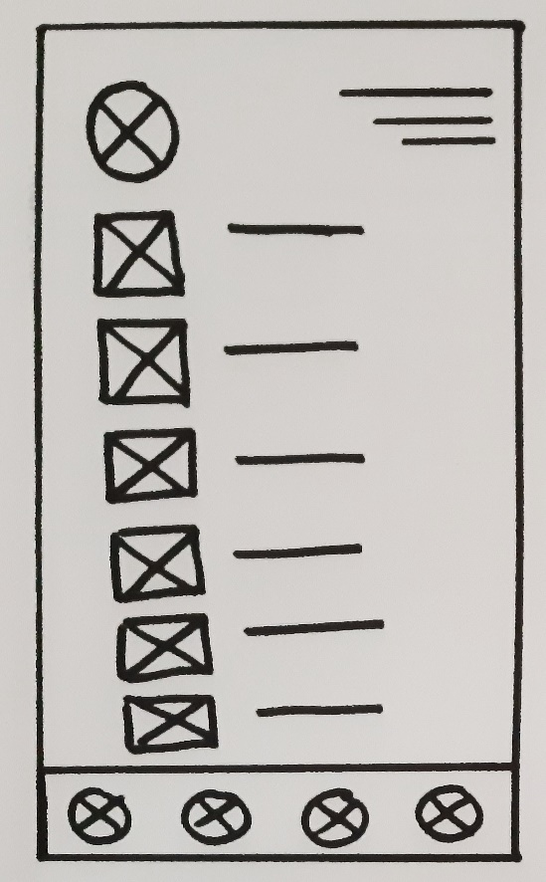

**Tutor Profile**

Tutor Details (Name / Faculty/Academic Year )

Edit Profile

Change password

My classes

My calendar

Publish study materials

My wallet

Logout (Hyperlink)

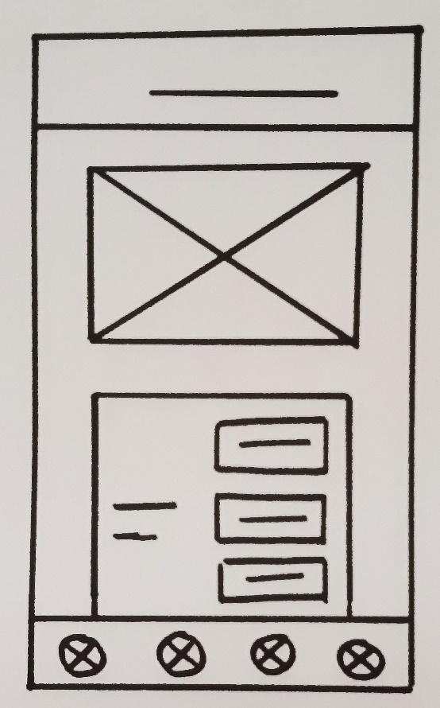

**Tutor’s Calendar**

Calendar with dates

Selected date component

Date

Schedule component with details

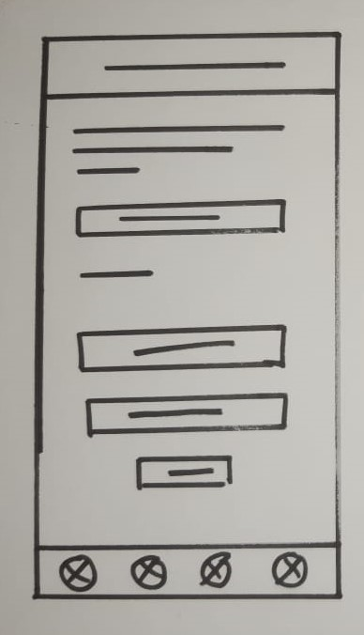

**Change Password**

Description about change password

Enter Current password

Forget Password hyperlink

Enter New Password

Confirm Password

Submit Password (Button)

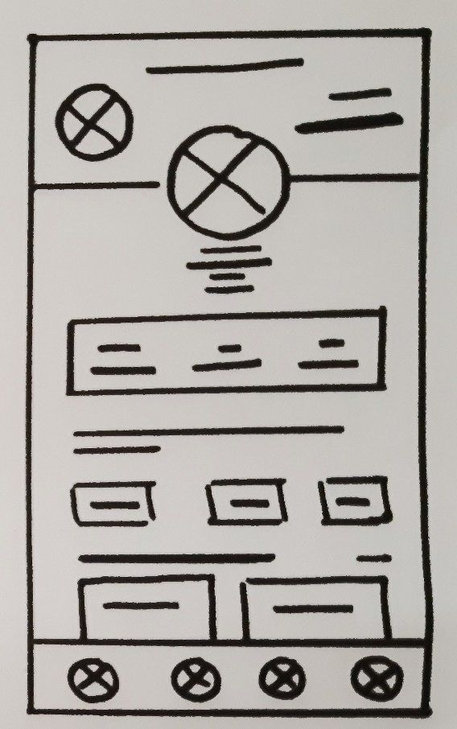

**Tutor Information**

Module name

Tutor details (Rank/ name / faculty / academic year)

Rating

Classes

Completed sessions

Modules names

Popular classes component

|  |  |
| --- | --- |
| IT21267772 | Kumanayake I. A |

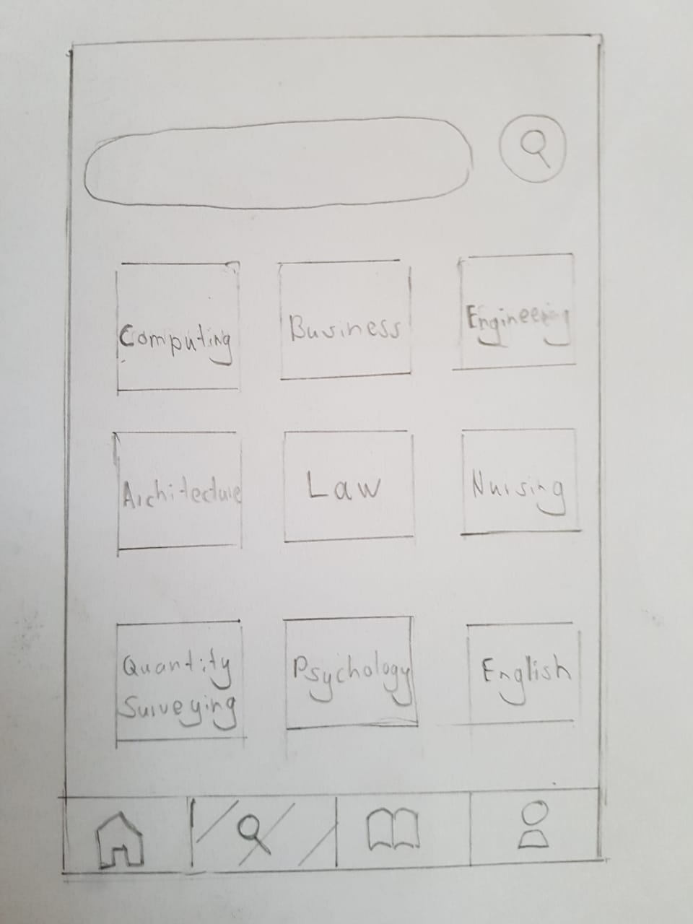

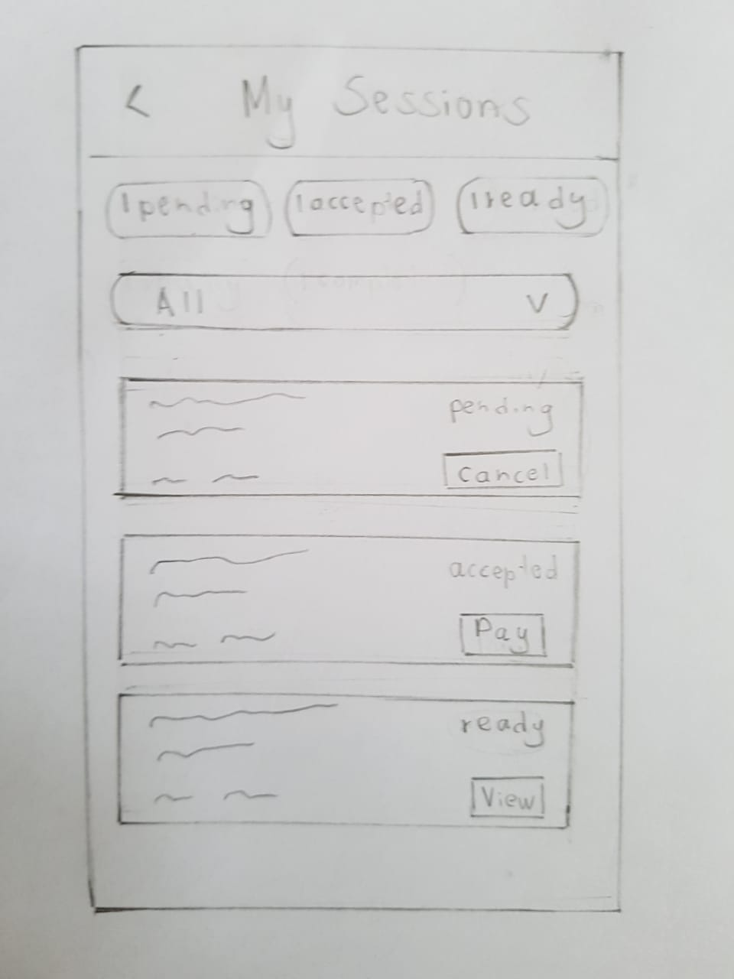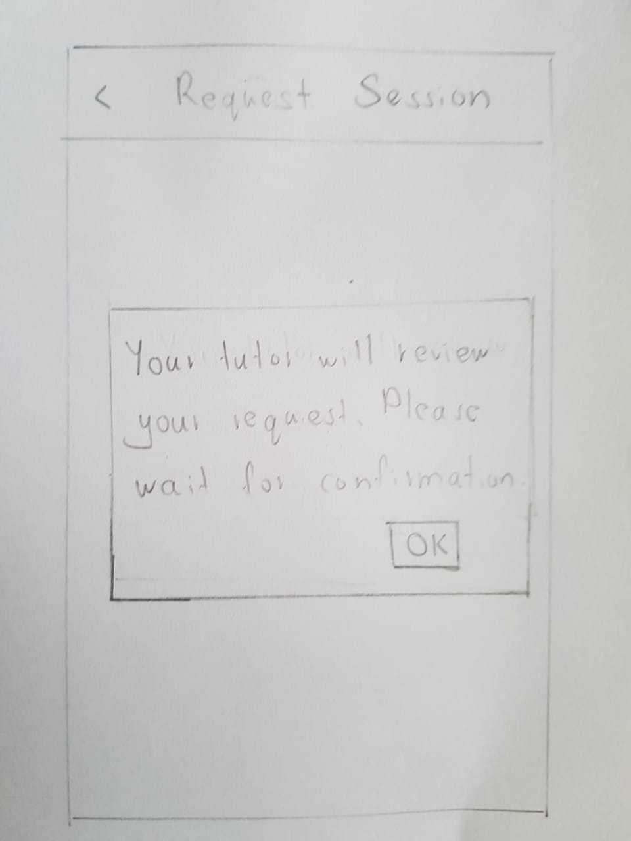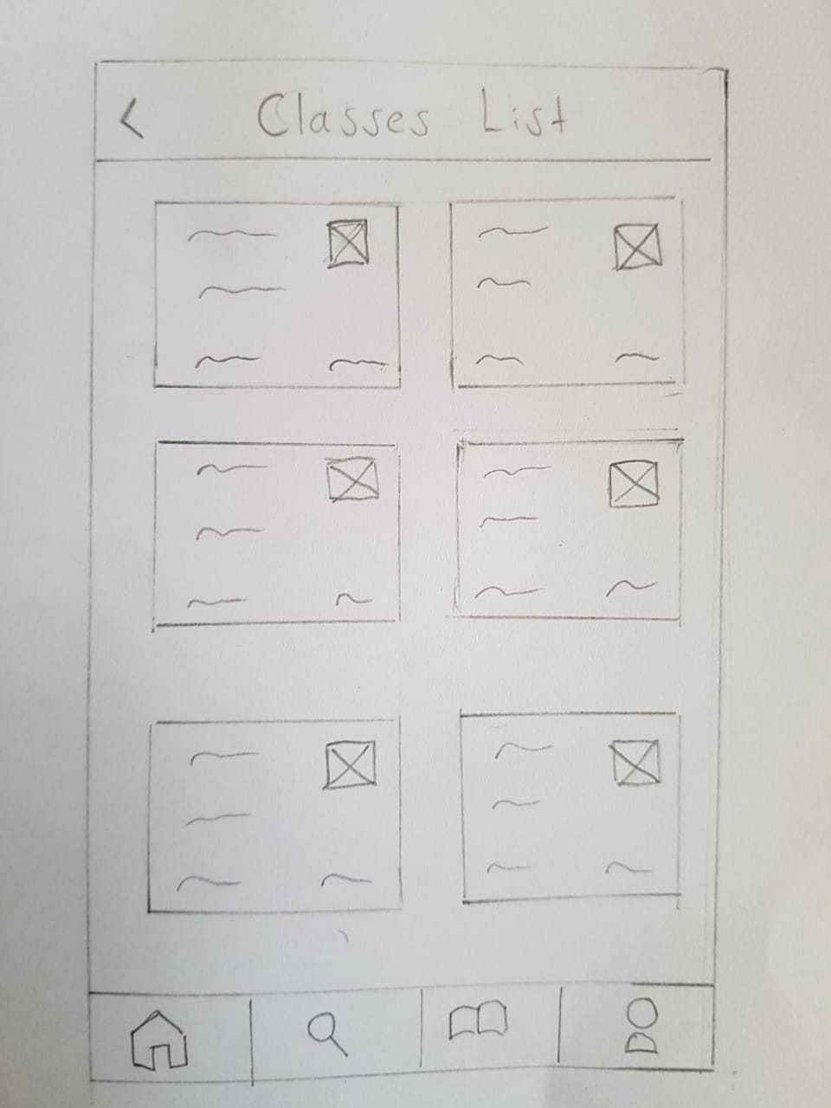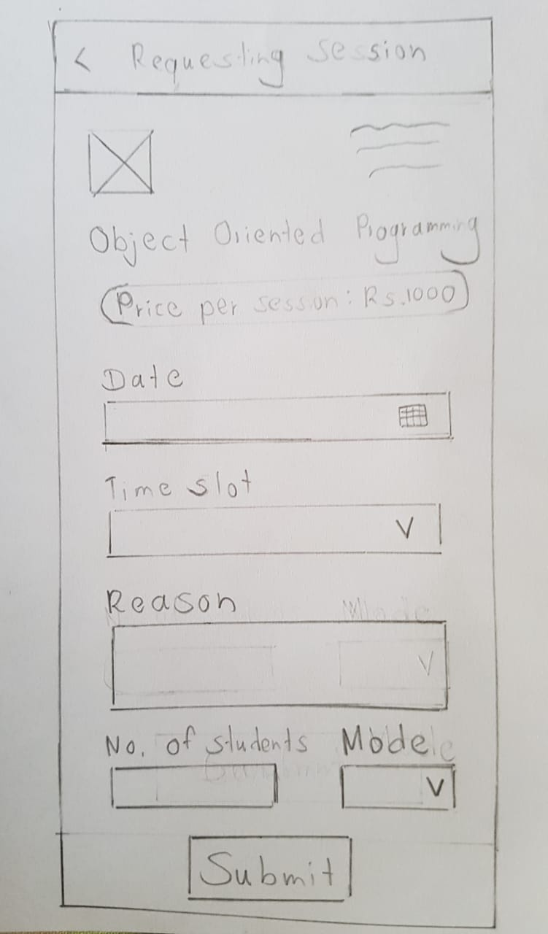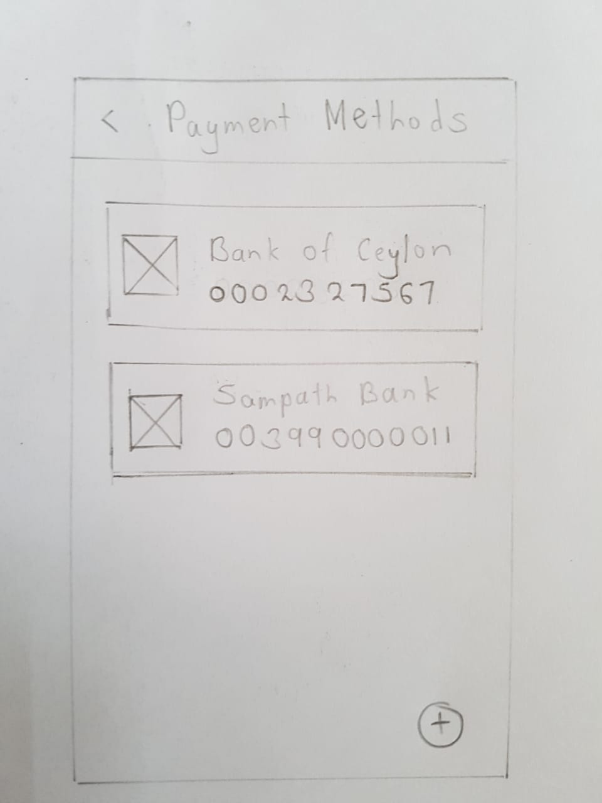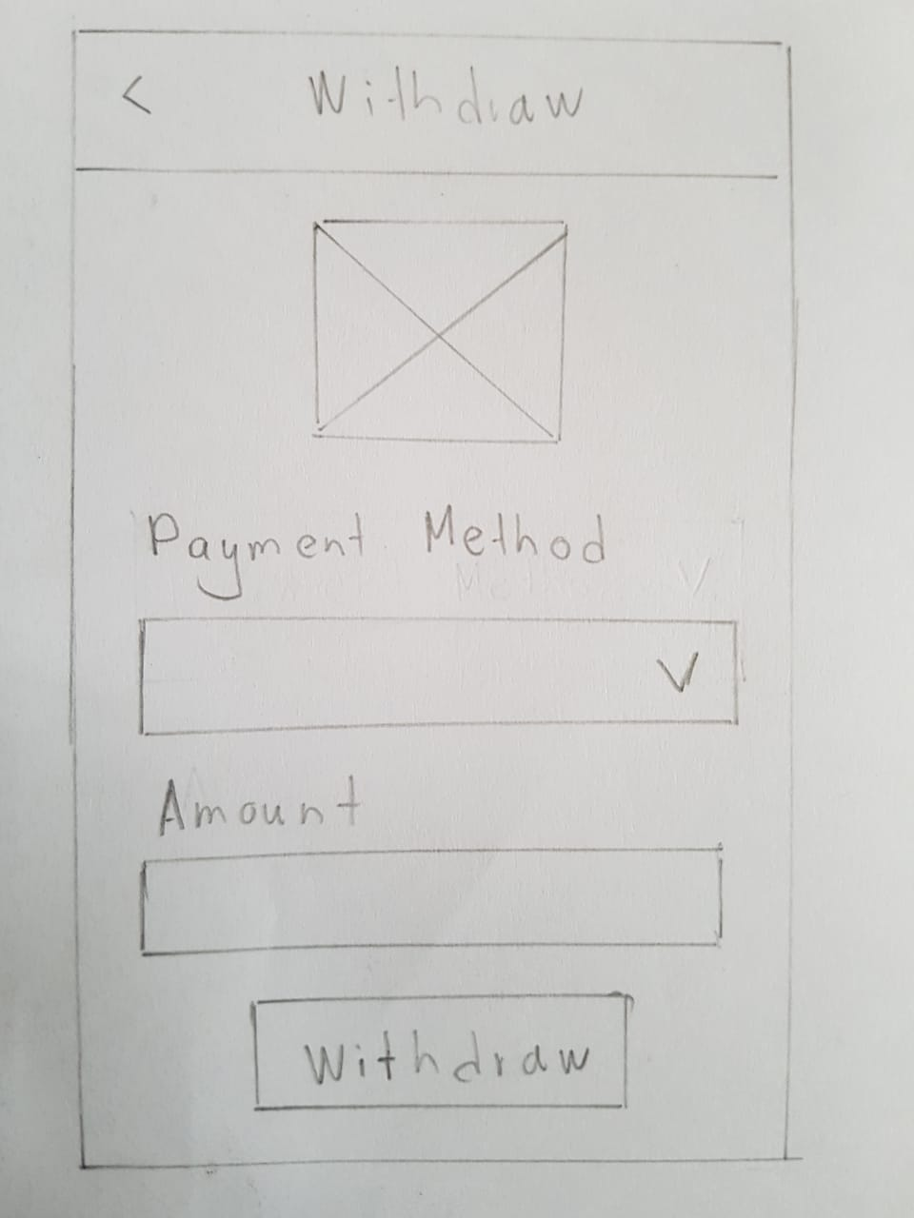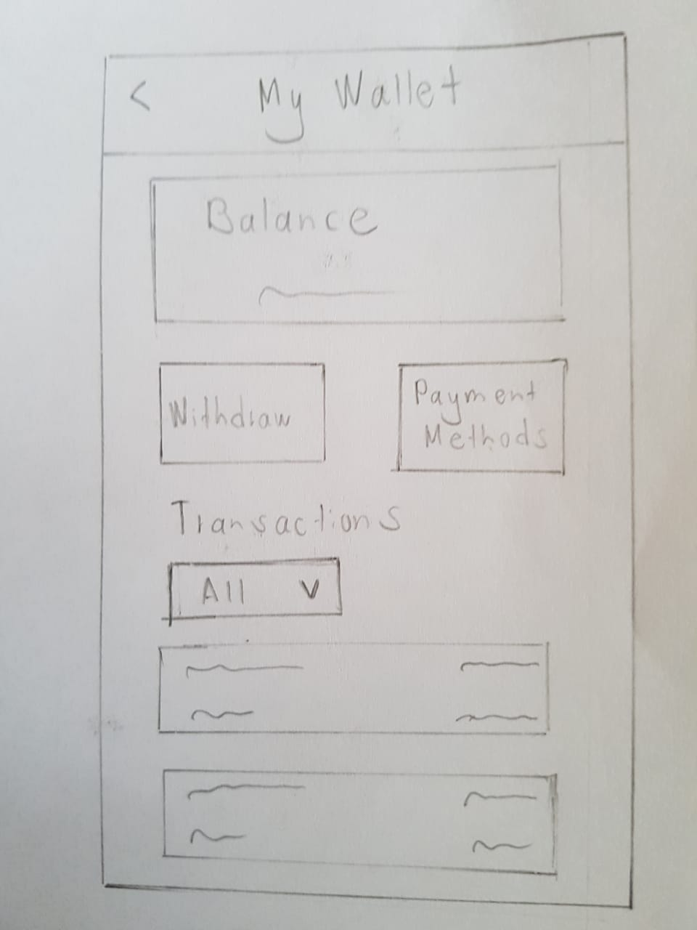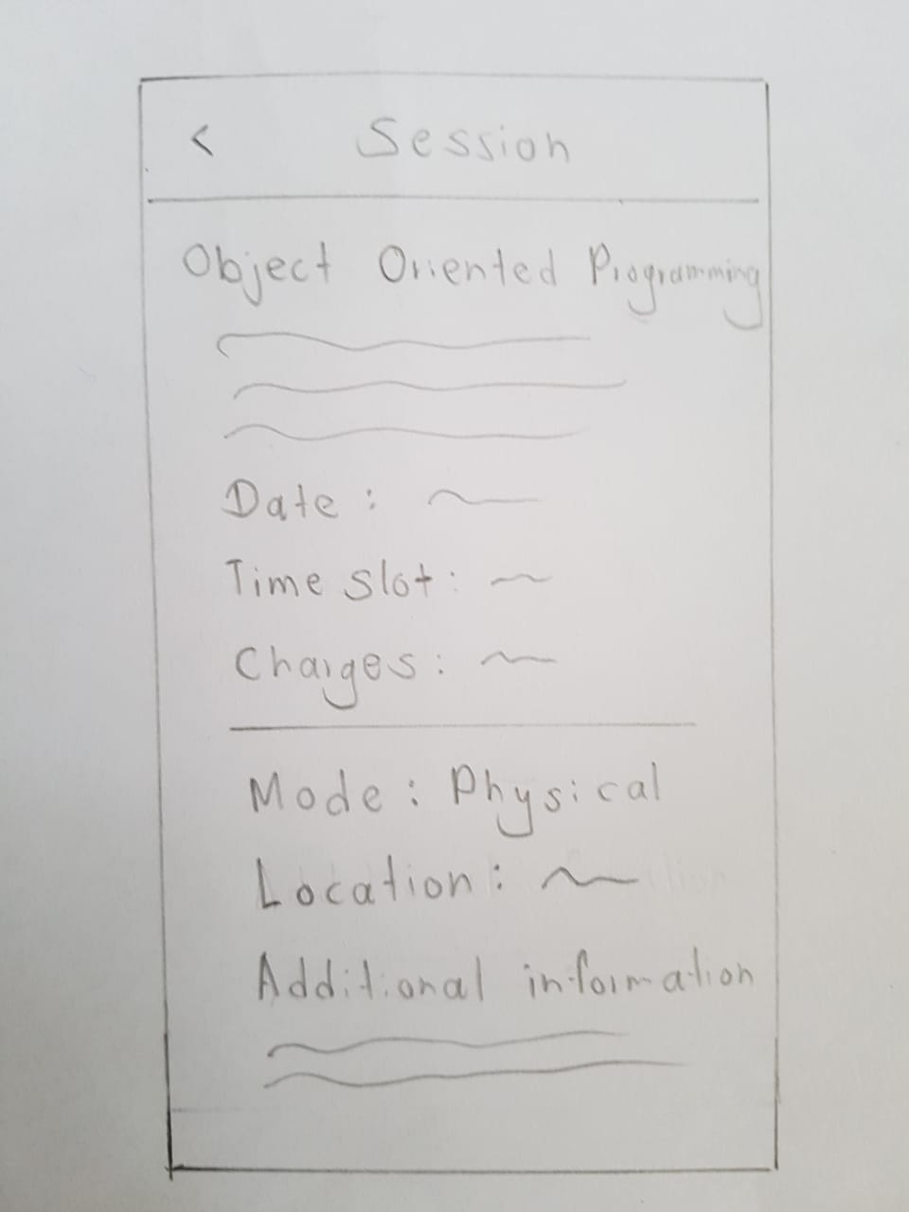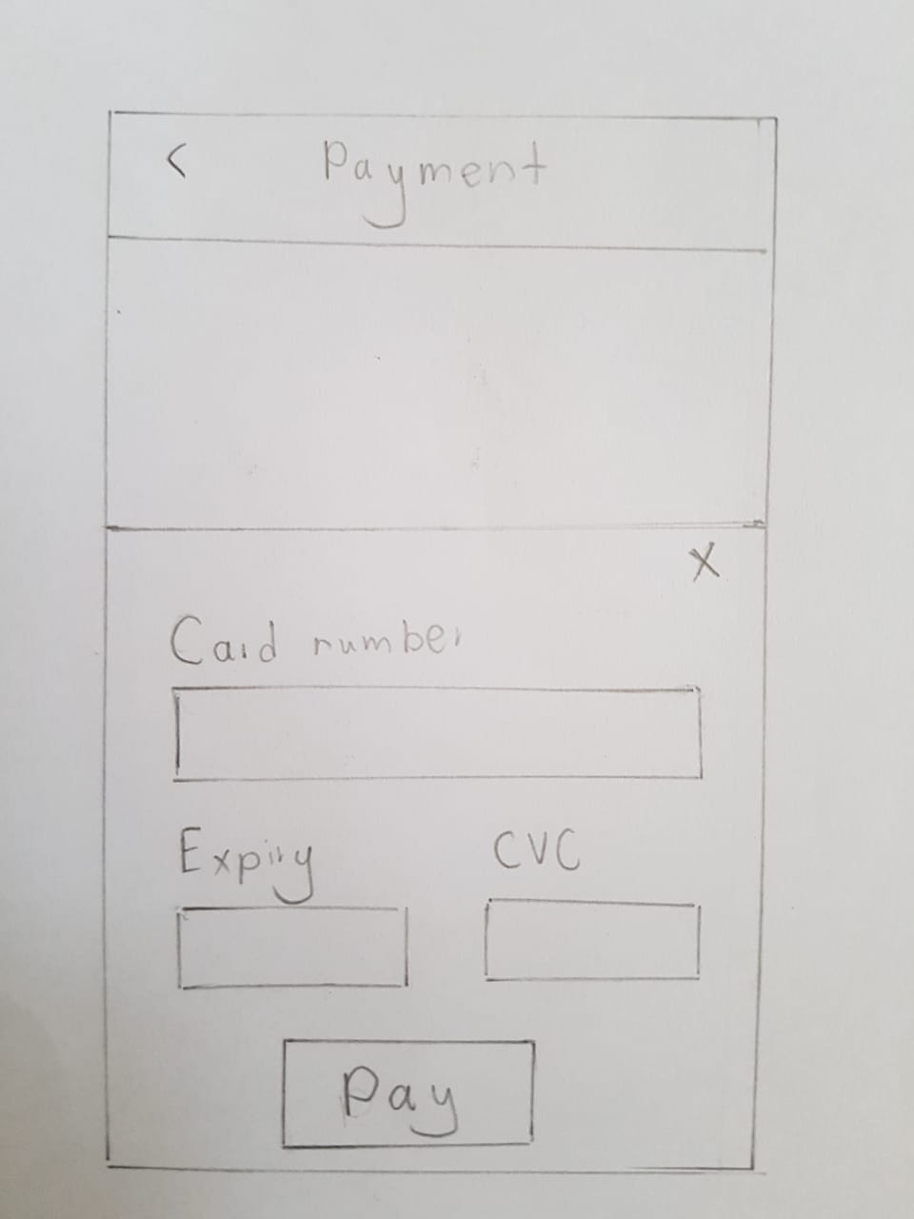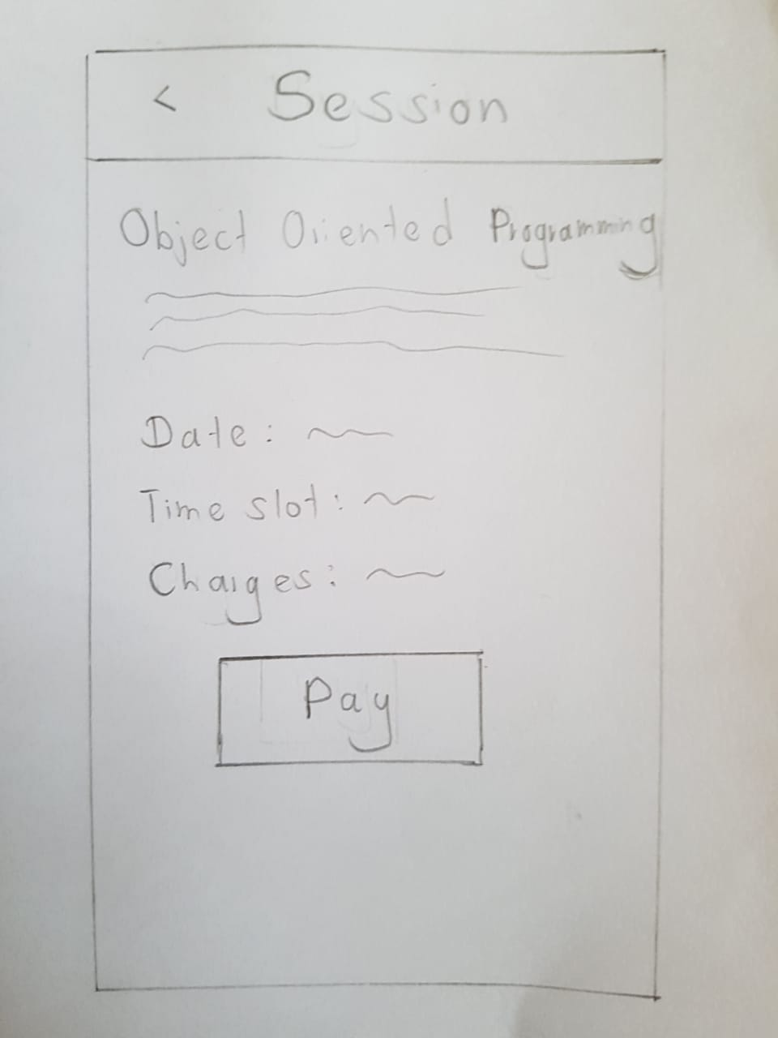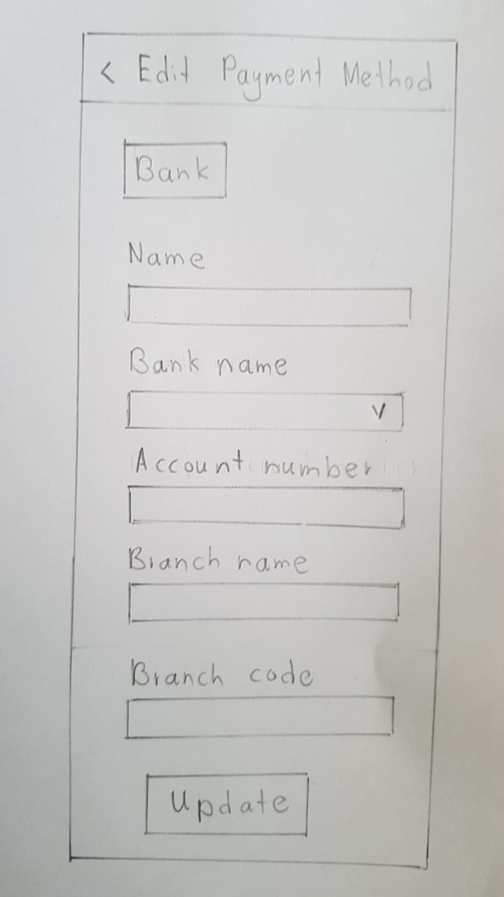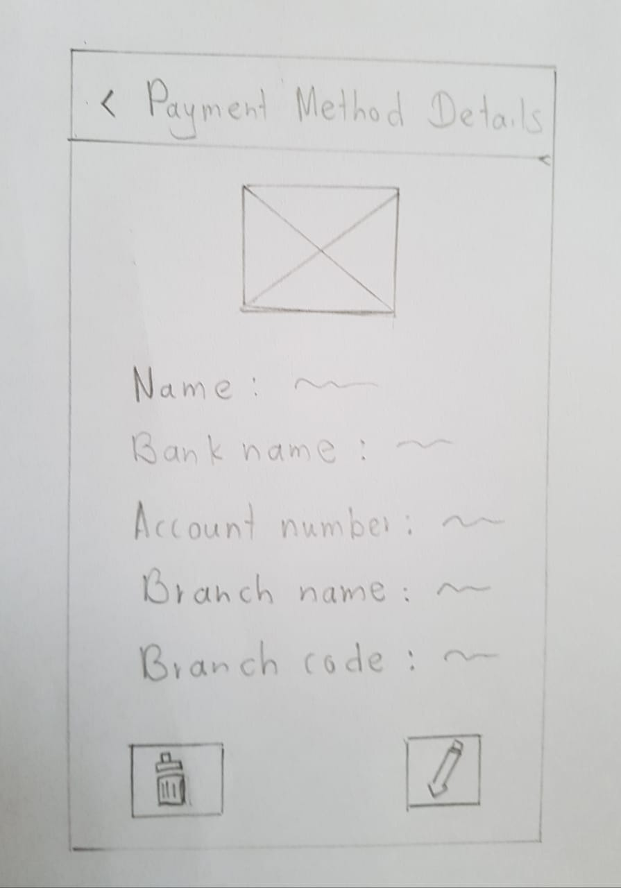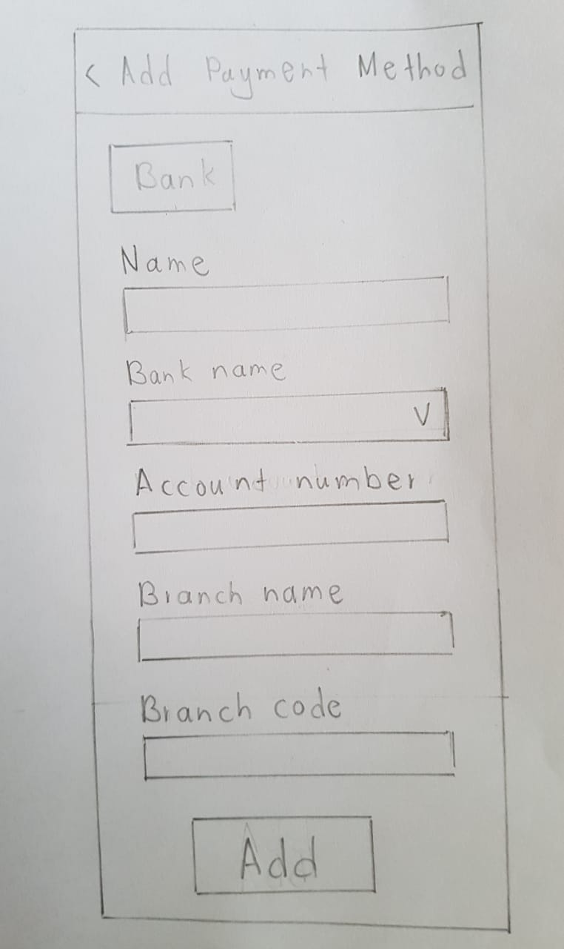

|  |  |
| --- | --- |
| IT21388934 | Siriwardhana S.M.R.R |

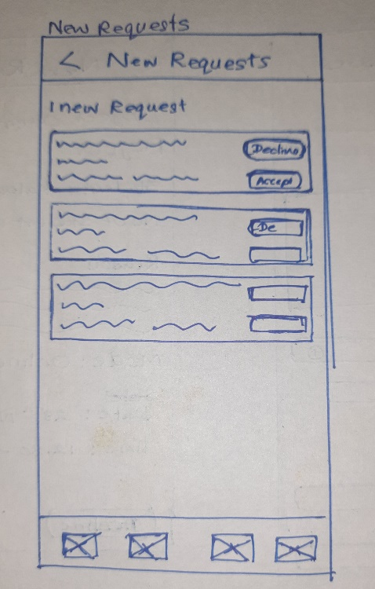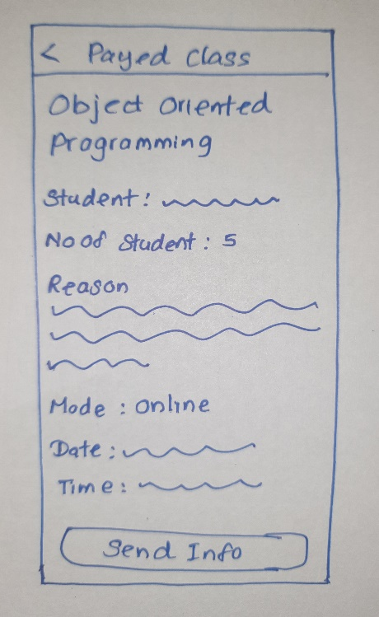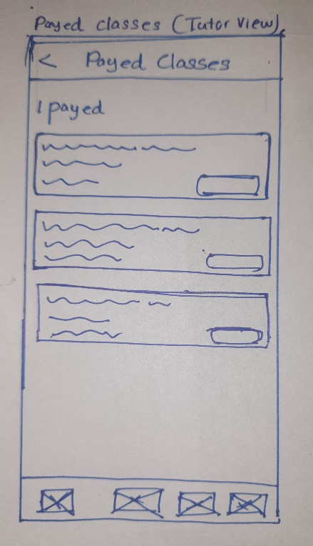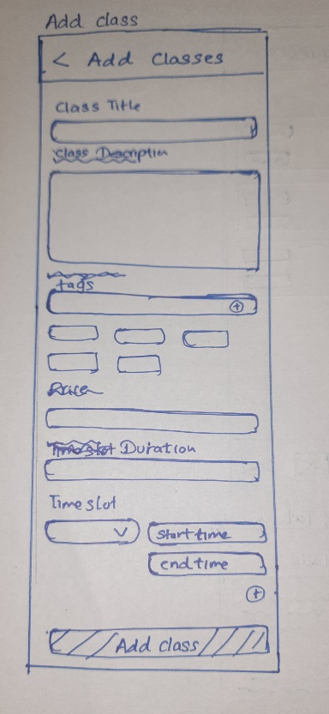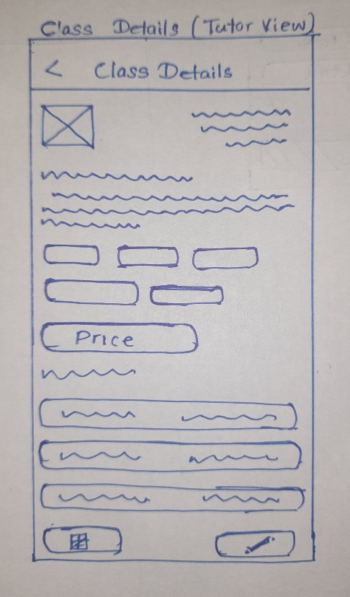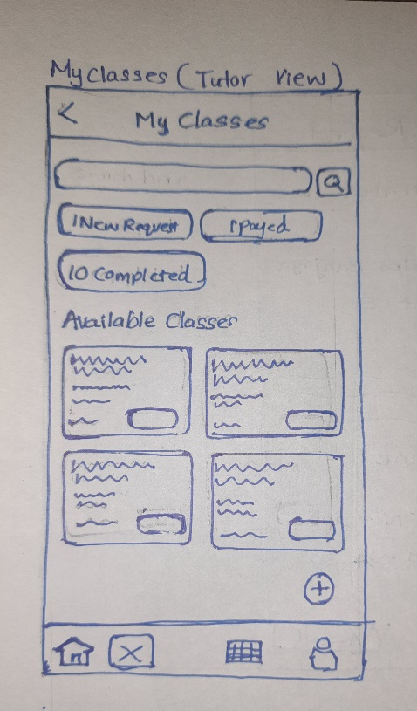

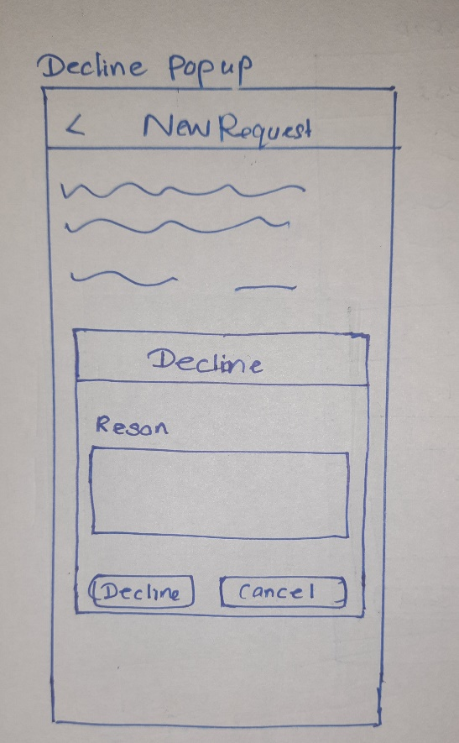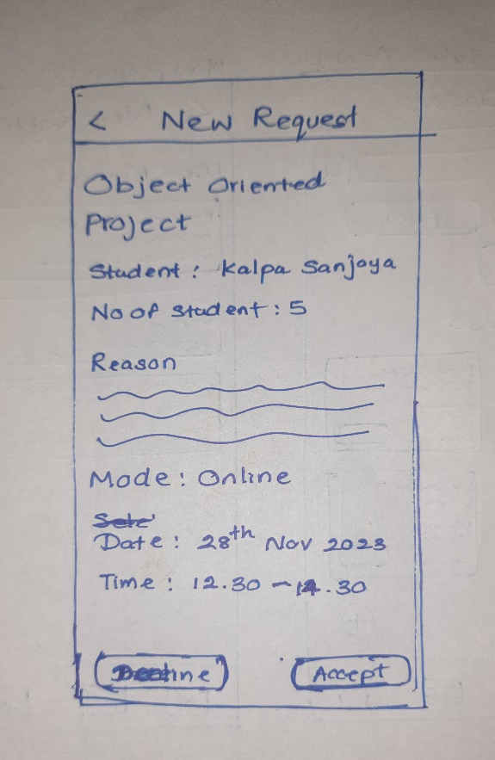

|  |  |
| --- | --- |
| IT21118340 | Kumarathunga S. A. D. S |

**Wire Frames**

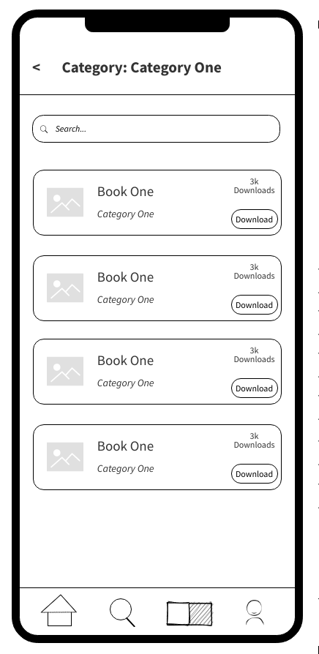

Student Profile

Student view of study materials

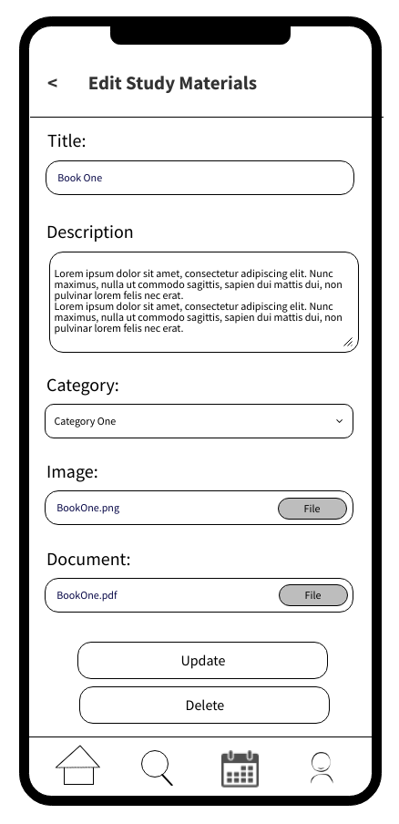

Tutor view of study materials

|  |  |
| --- | --- |
| IT21291364 | Rashen W.G.M |

Tutor Login, sign up and Forgot password

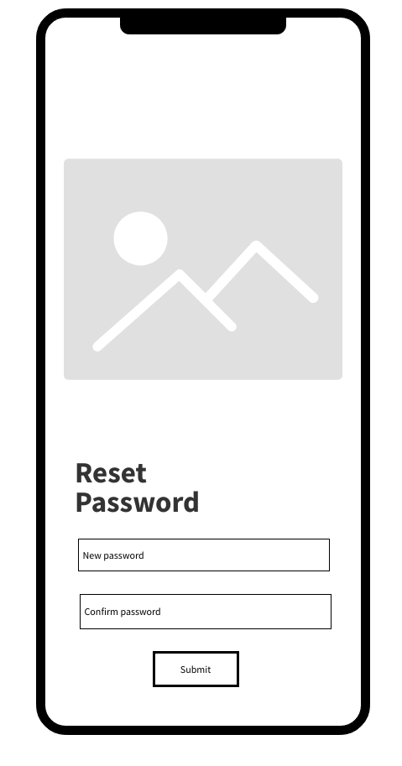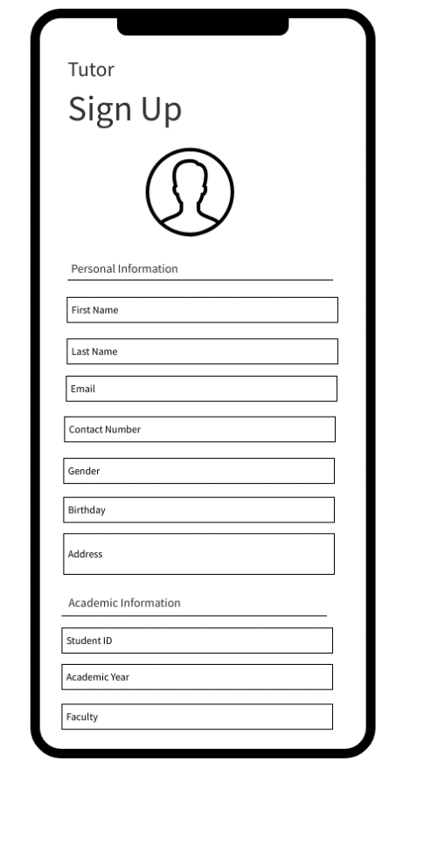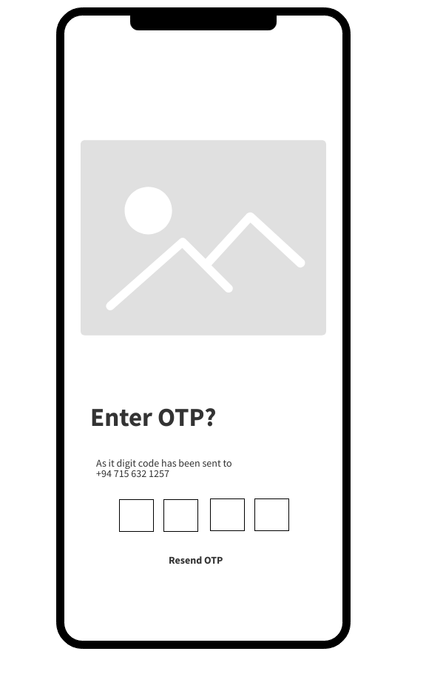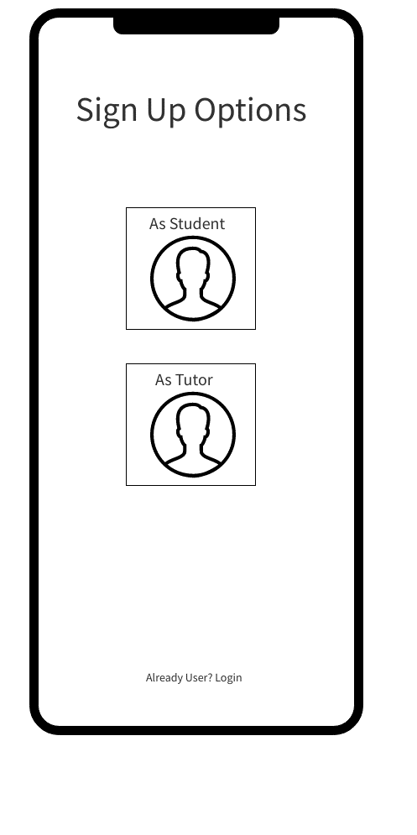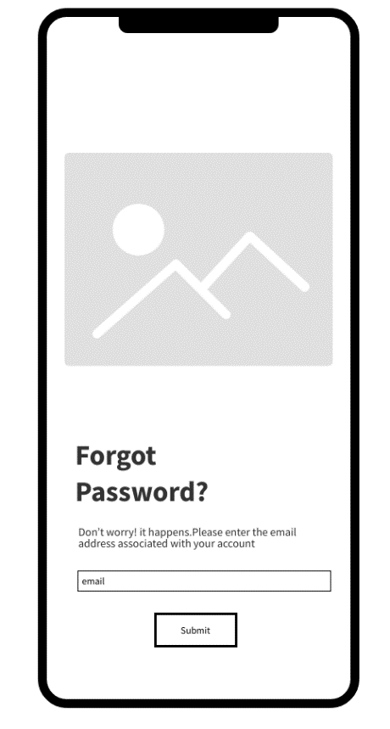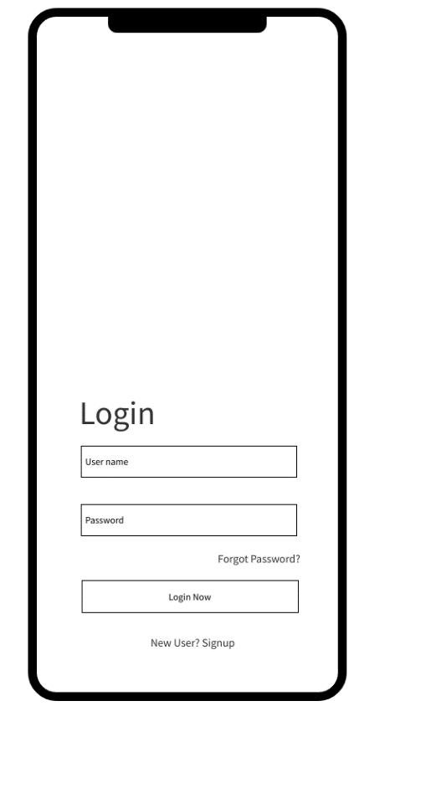

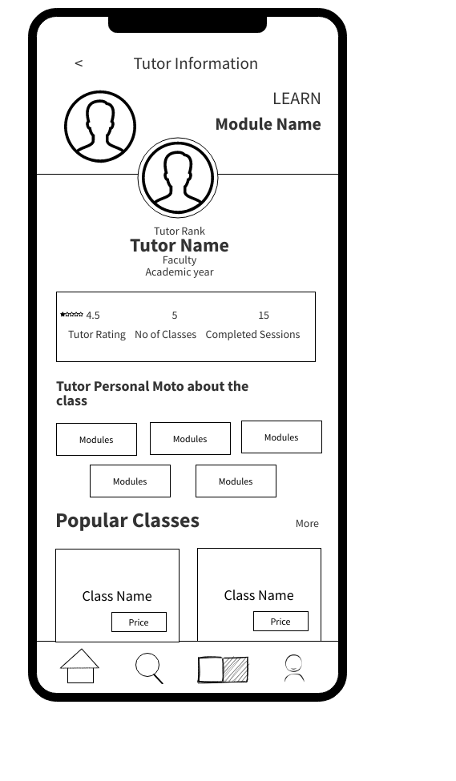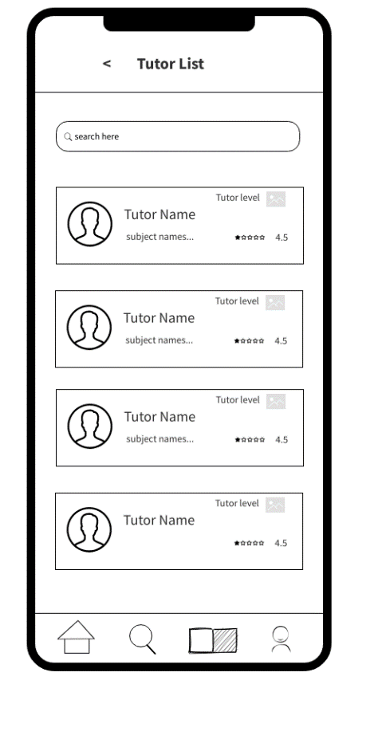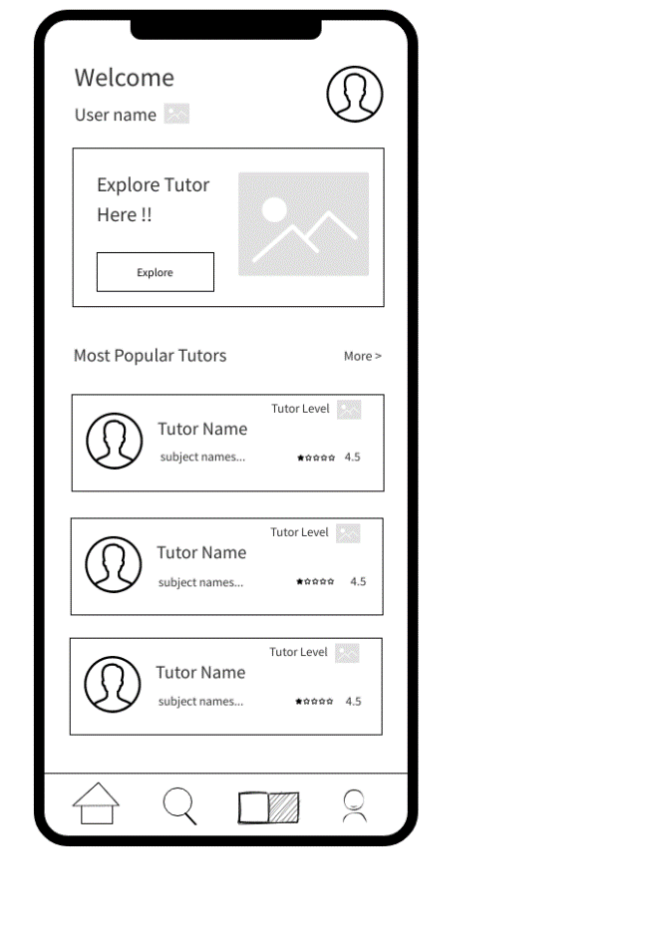

Tutor view of tutor’s profile

Student view of tutors’ list

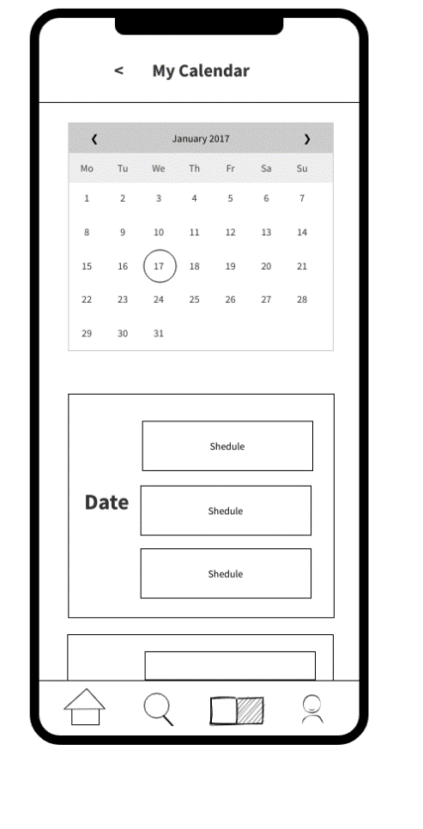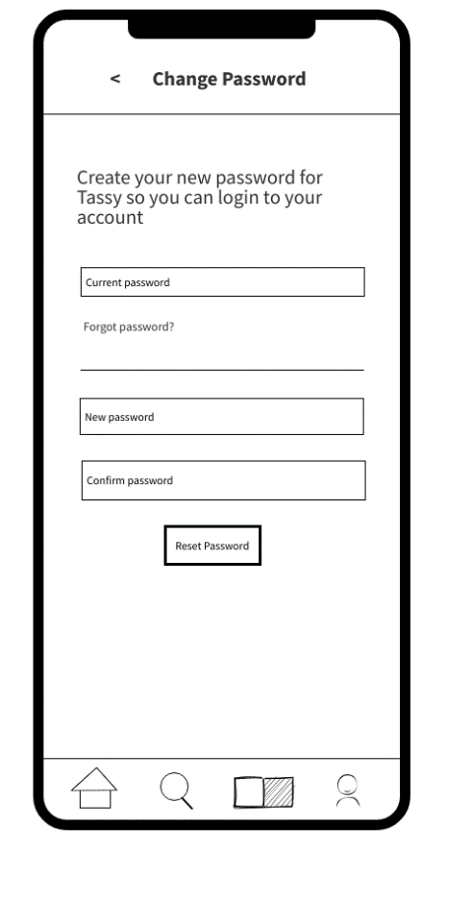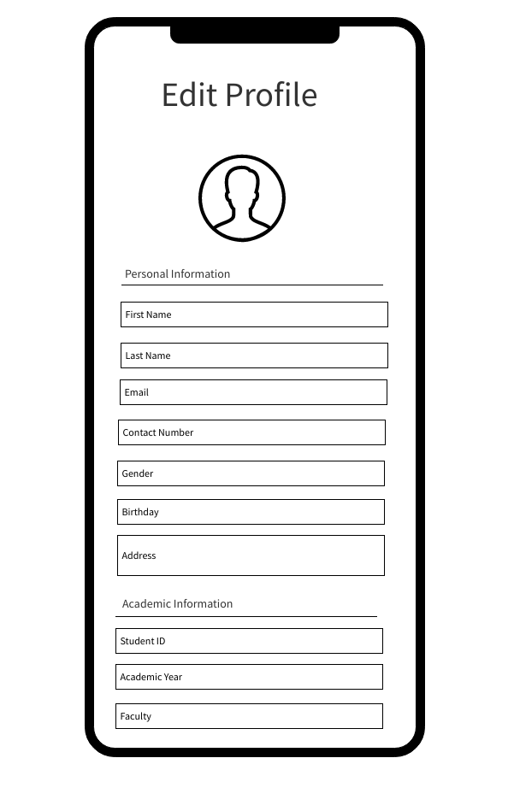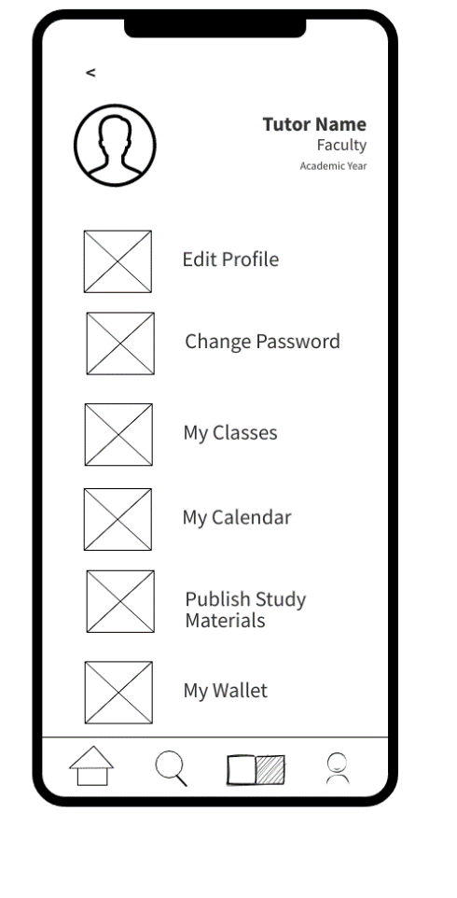

Tutor edits profile, change password and calendar.

|  |  |
| --- | --- |
| IT21267772 | Kumanayake I. A |

Student selects subject, find relevant tutor, and book a class.

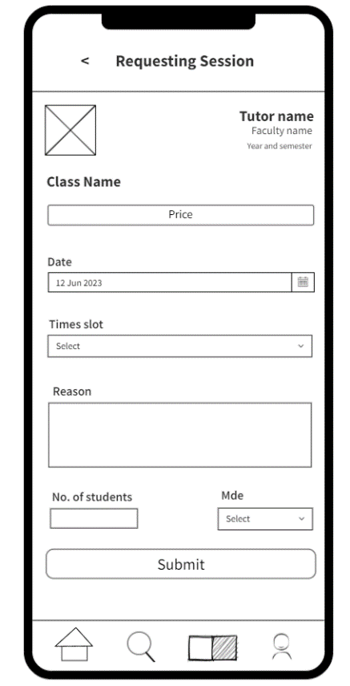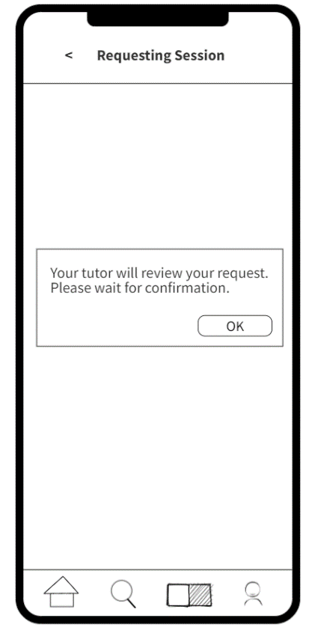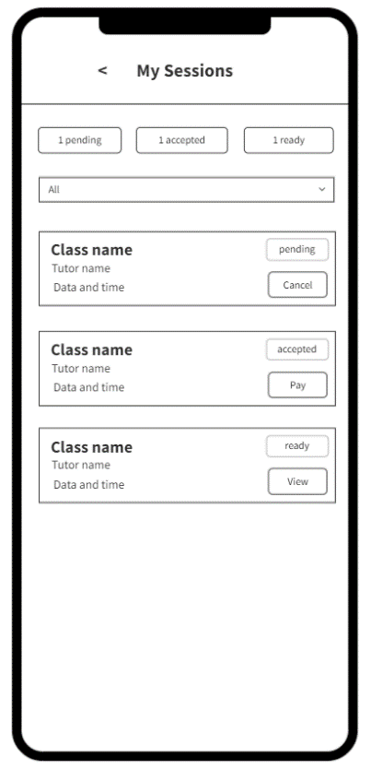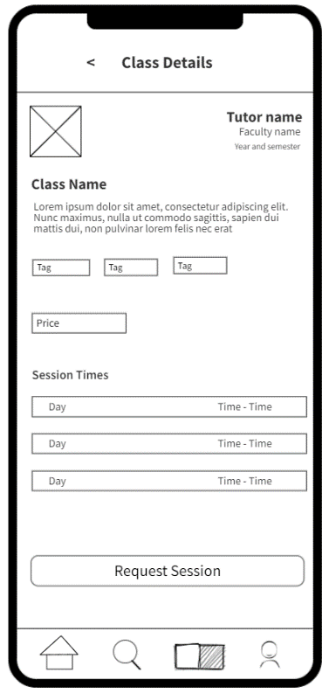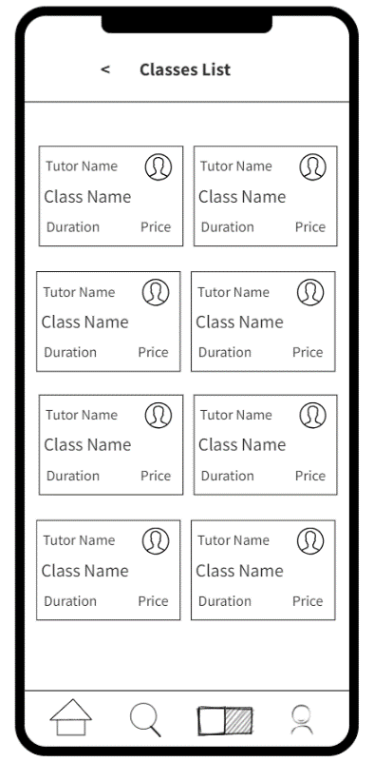

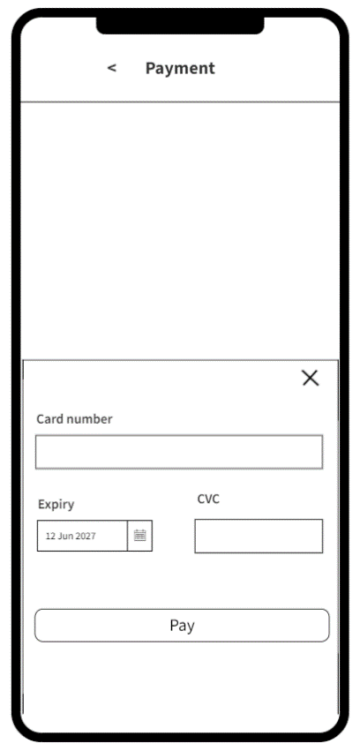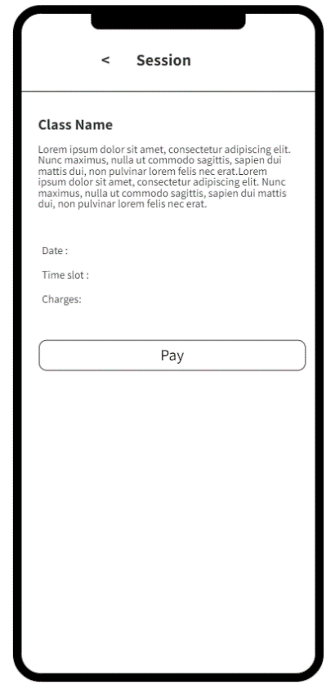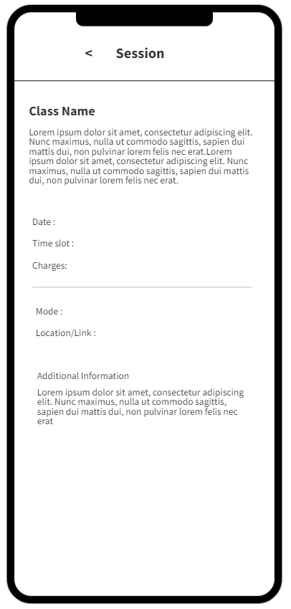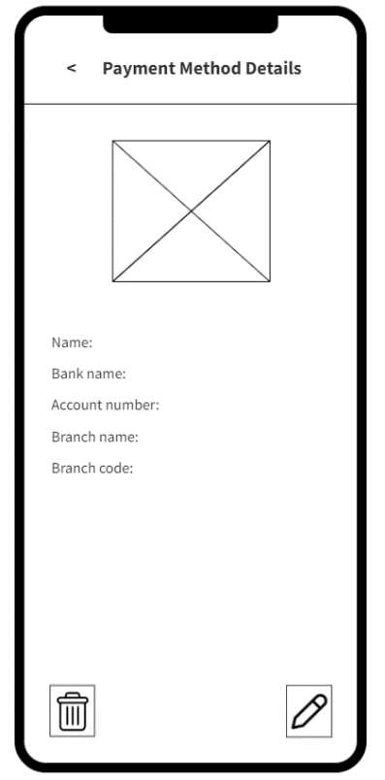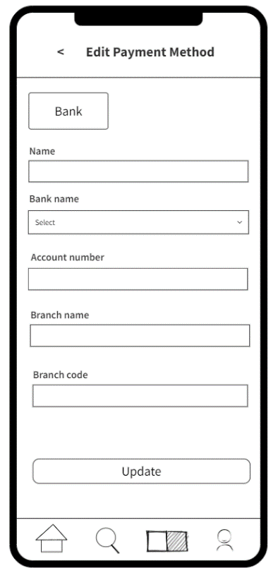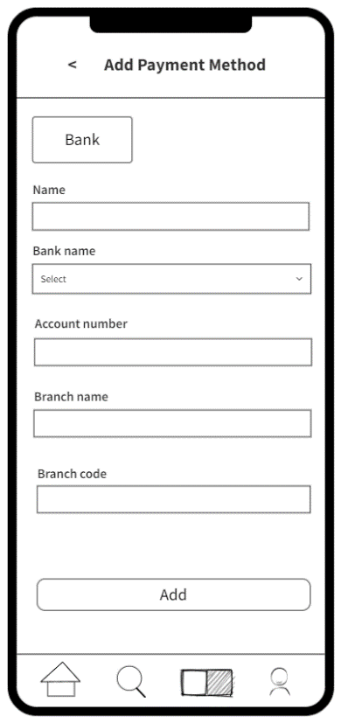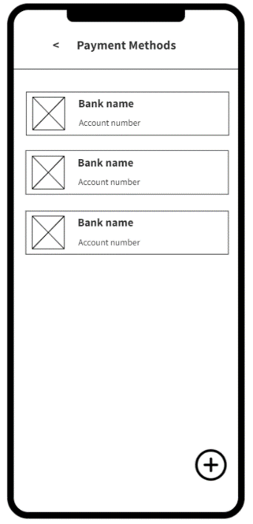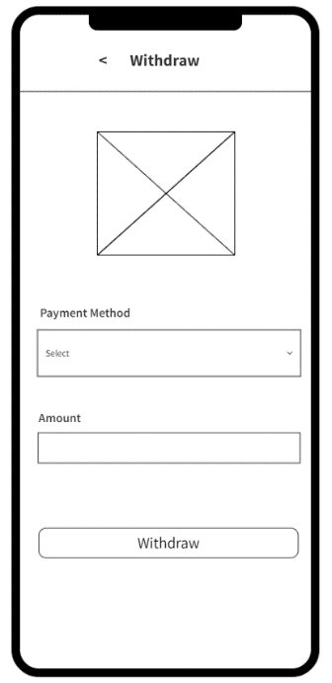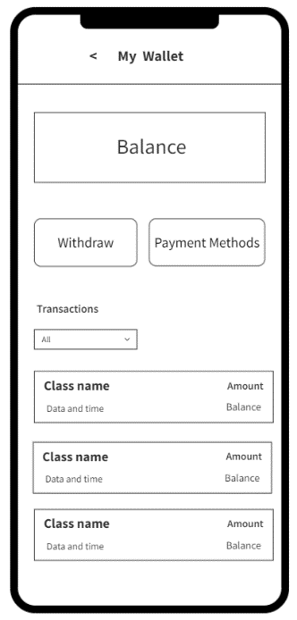

Student makes payment to a tutor accepted class.

Tutor withdraws money, add payment method, and edit payment method.

|  |  |
| --- | --- |
| IT21388934 | Siriwardhana S.M.R.R |

Tutor view, add and edit class details.

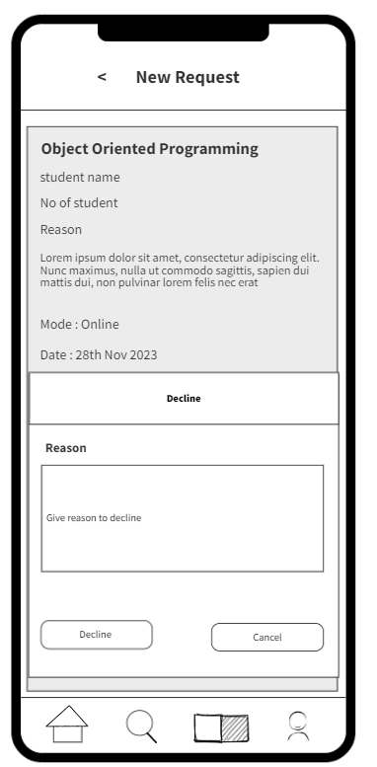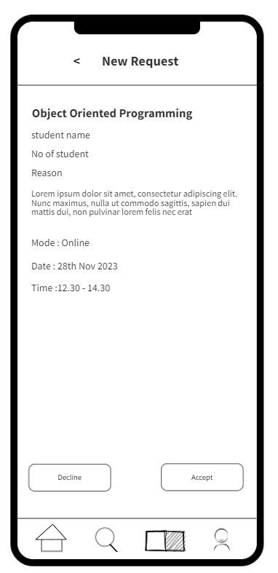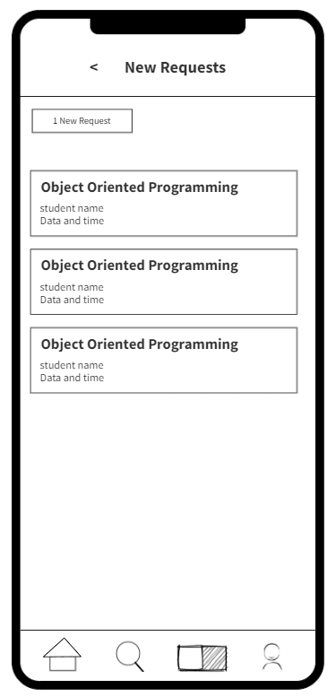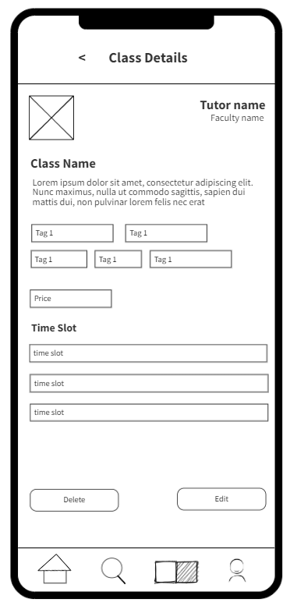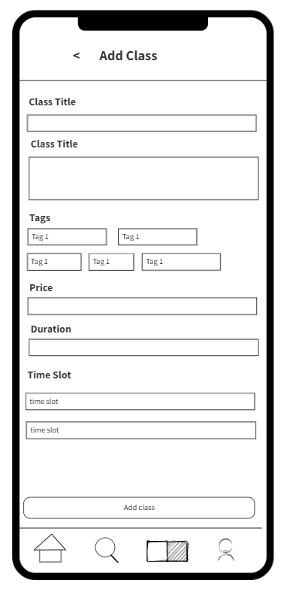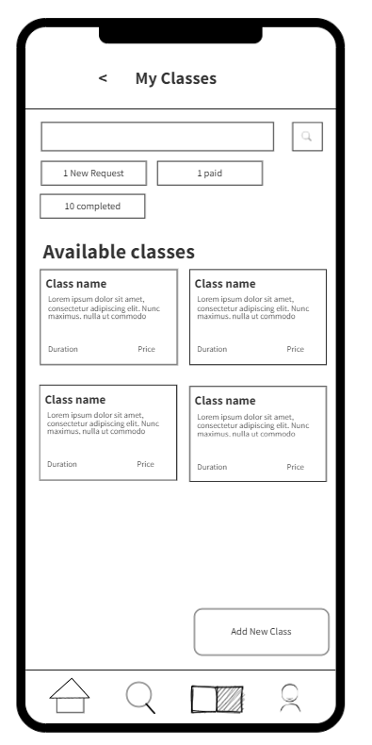

Tutor view accept and decline new requests.

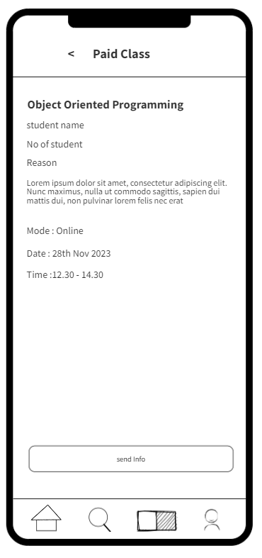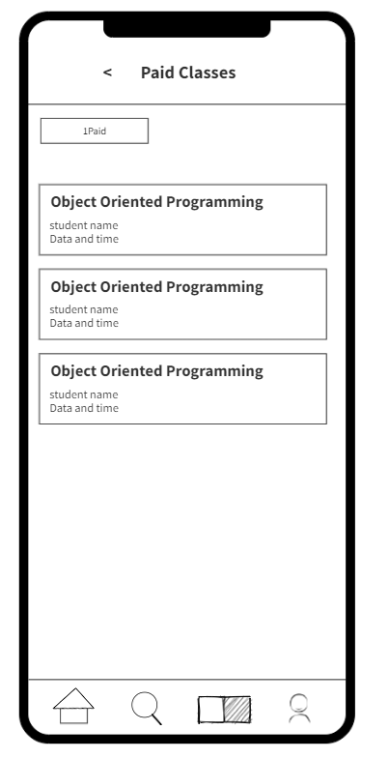

Tutor view paid classes and send info to student.